V3-word format

# MOUKA EMMANUEL

# FACTS & EVIDENCES

**ASSASSINATION ATTEMPTS, ROBBERIES, ARSON ATTEMPTS, FOOD POISONING**

**WRONGFUL DETAINMENT OF A VICTIM**

**DETAINED AT AGBOR POLICE FOR BEING RUDE**

**WRONGLY ACCUSED OF MURDER BY A COMPLAINANT AFTER BEING TRANSFERRED TO DELTA STATE POLICE COMMAND, ASABA, DELTA STATE**

**OFFICERS ONYEAMA AND BLESSING WERE THE INVESTIGATING POLICE OFFICERS**

**OFFICER YAKUBU, O/C HOMICIDE WAS IN CHARGE OF THE INVESTIGATING POLICE OFFICERS**

**REMANDED AT AGBOR PRISON, DELTA STATE, THE JUDGE DECLARED THE REMAND REQUEST NOT LEGAL BUT I WAS STILL REMANDED**

**YET TO PRESS CHARGES FOR THE ATTACKS WHILE NOTIFYING THE MINISTRY OF JUSTICE, ACCUSERS AND POLICE TO VERIFY THESE CLAIMS AND DROP CHARGES AGAINST MOUKA EMMANUEL AT UMUNEDE HIGH COURT, UMUNEDE, DELTA STATE**

**Intro**

I am Mouka Emmanuel, I work with Neural networks and artificial intelligence Limited (NNAI) as

a researcher and operations manager at Alihame, Agbor, Delta State, Nigeria. I study at

Lancaster University Ghana. My company specializes in security, counter surveillance. I plan to

join the Nigeria Police Force in 2021/2022. I have experience as a Private investigator.

Nature of events

1. I experienced attempts to rob and kill me and residents at my premises from 2021-2022. The

armed robberies started with theft of power generators, next, electrical materials and other

items were stolen. Progressed to poisoning of food and drinks in the premises which led to near

death experiences. Unknown persons tried to electrocute residents to death by placing a power

source on a metal door. Armed criminals regularly attack the premises fence during nighttime to

destroy the fence and property, the fences were re-enforced with metal rods to prevent collapse.

A CCTV system was acquired to identify the criminals. The attackers regularly damaged the

CCTV system. A CCTV Log book (Photo E1) was acquired to document the events.

On 12 February, 2022, Agbor Police was invited to the premises. A Police Officer named Duke

Amerika asked if there were suspects in the absence of video evidence. As at that date, I did not

have suspects. I sent 70,000 Naira(Photo E2) to the Police Officer in appreciation of his visit.

The attacks progressed to direct confrontations at my premises by armed persons without

cause. They attempted to kill me with witnesses present. I was saved by the intervention of two

persons during one of these attacks.

On multiple occasions I have met persons hurt at the premises, the local pharmacy treated such

persons. They claimed they got injured while performing their tasks. On an occasion, I

discovered one of the injured persons entered a locked section and left a blood trail.

I was detained without cause after experiencing several armed attacks while seeking police

assistance. While in police custody, they refused to take my statement and ignored my

complaints that the threats are still existent. Another armed attack occured while detained. My

family and staff was put in danger and considerable portions of my property was destroyed. The

police advised I should write an accidental discharge occured, I refused.

**Major events and dates:**

On 27 September 2021, suspicious events occured(armed robbery), observing the CCTV system

showed scenes being replayed. This is evidence of tampering. (Photo E1)

On 28 September 2021, suspicious events occured(ACT OF GOD). (Photo E1)

On 31 September 2021, suspicious events occured(armed robbery), the CCTV system

failed(DVR failure). It was impossible to get video evidence of the events that occured. (Photo

E1)

On 31 September 2021, suspicious events occured(armed robbery), the CCTV system had no

video evidence available. An auto format was triggered which damaged video evidence. (Photo

E1)

On December 2021 - January 2022, suspicious events occured(armed robbery), blackout on

CCTV system. (Photo E9)

On 25 January 2022, suspicious events occured(armed robbery, food poisoning suspected), the

door was left unlocked after the incident. (Photo E1)

On 12 February 2022, Agbor Police was invited to the premises, Officer Duke Amerika received

complaints of theft, armed robberies, others attacks and advised it could be spiritual if the

attackers were able to carry out attacks and tamper video evidence. 70,000 Naira was given to

Office Duke Amerika in appreciation of his visit and expectation of action to identity and arrest

the criminals. (Photo E2)

On 16 February 2022, suspicious events occured(armed robbery, forced entries which damaged

doors, poisoning suspected). Suspects were identified but gave excuses that they acted in error

and gained access because doors were left open, this claim was untrue as the doors are always

locked for security reasons. (Photo E1, Photo E3)

On 18 February 2022, suspicious events occured(armed robbery, forced entries which damaged

doors, poisoning suspected). Suspects were identified and gave excuses that they acted in error

and that the doors were left open, this claim was untrue as the doors are locked for security

reasons. Efforts were increased to prevent such entries such as notifying persons not to enter

and notifying staff to keep the gates and doors locked at all times. (Photo E1, Photo E4)

On 21 February 2022, suspicious events occured(thefts, poisoning suspected), the CCTV

system experienced blackouts suspected to be from the attackers. This event exposed the solar

power system as not charging from sunlight. Considerable financial damaged was suffered

during this event. (Photo E1, Photo E5, Photo E6)

On 4 March 2022, suspicious events occured(thefts, poisoning suspected), the CCTV system

experienced blackouts suspected to be from the attackers. The premises experienced power

failure suspected to be intentional bridging of the power system. (Photo E1)

On April, 2022, suspicious events occured(assassination attempts), an assassination attempt

where I was saved by two persons, Okafor and Emmanuel. I took action after the failed

assassination attempt to report to my family, the Agbor Police and seek solutions. (Witnessed)

On 19 April 2022, suspicious events occured(thefts, assassination attempts, poisoning

suspected), multiple attackers were at the premises. I was saved by Okafor and Emmanuel

during the previous attack. I was detained while seeking Police assistance without cause. All

appointments were closed at 3pm, notice was given to all persons including staff on site.

Engr.Emmanuel who was on-site received a notice to end all activities at 3pm. The premises did

not receive or grant entry to anyone past 3pm. (Photo E11)

On 19 April 2022, Agbor Police Officer Duke Amerika visited the premises. Officer Duke received

the reports of robberies on February 12, 2022 when he was invited and is the first person

notified of incidents at the premises. (Photo E7)

On April - May 2022, suspicious events occured(thefts, assassination attempts suspected),

Considerable portions of my property was destroyed by armed attackers. They had previously

tried destroying the property before I expanded through acquisition of the neighbouring land. I

reported to the investigating police officers while in custody. They did not act on the report as at

the time of the incidence. (Photo E8)

I requested my family members report the incident while detained, they notified me that Agbor

Police stated the attack was malicious damage and did not incident the report as at the time my

family reported. The attackers have made efforts to kill me and residents, a failed assassination

attempt should not be classified as malicious damage and if it was, no arrests have been made

to get confessions on the reasons I am being targeted. (Witnessed)

On 21 November 2022, I requested for assistance from Police Officer Nkiruka who took action

to investigate my complaints and incident the attacks at Agbor Police station. (Witnessed,

incidented)

Methods of entry

The armed attackers confronted me directly on multiple occasions, the known methods of

entry are through the fencing, breaking the doors of offices/rooms/kitchen with visible damage,

the front gate through an unknown means as it is always locked, the roof and other unknown

entry points. (Photo E10)

Human rights contact

On 15 June 2022, I contacted National human rights commission (NHRC) Asaba, Delta State,

Nigeria. Ngwu Alphues assigned Okechukwu .N to assist me with the situation. I provided the

account of events, provided the witnesses to the assassination attempts and was requested to

provide a detailed account of challenges suffered.

**E1 - CCTV Log Book**

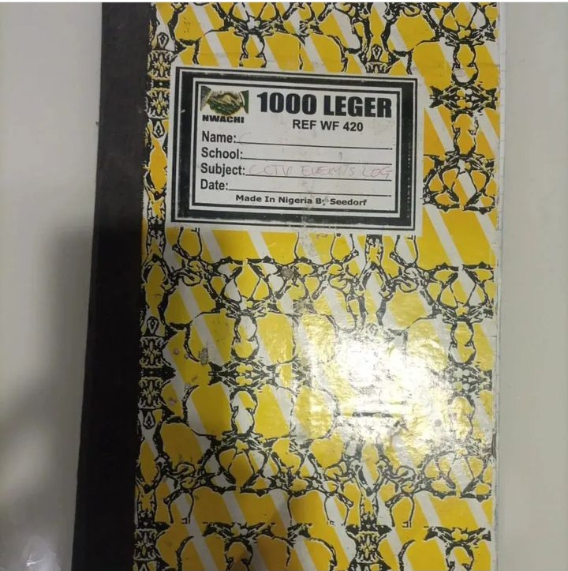

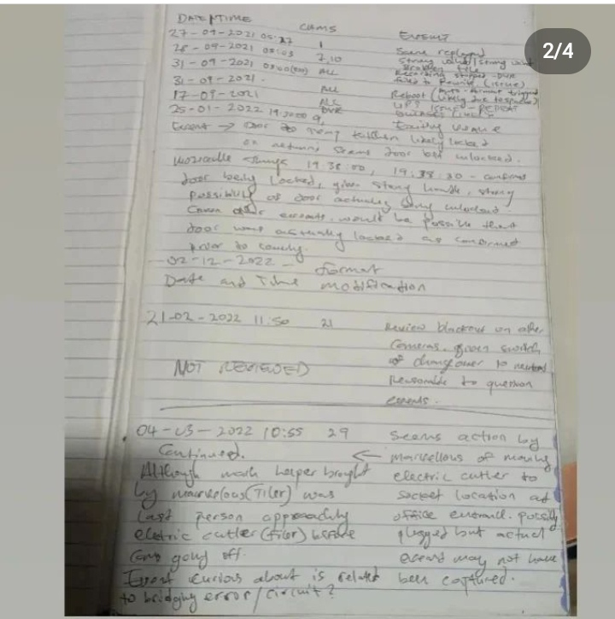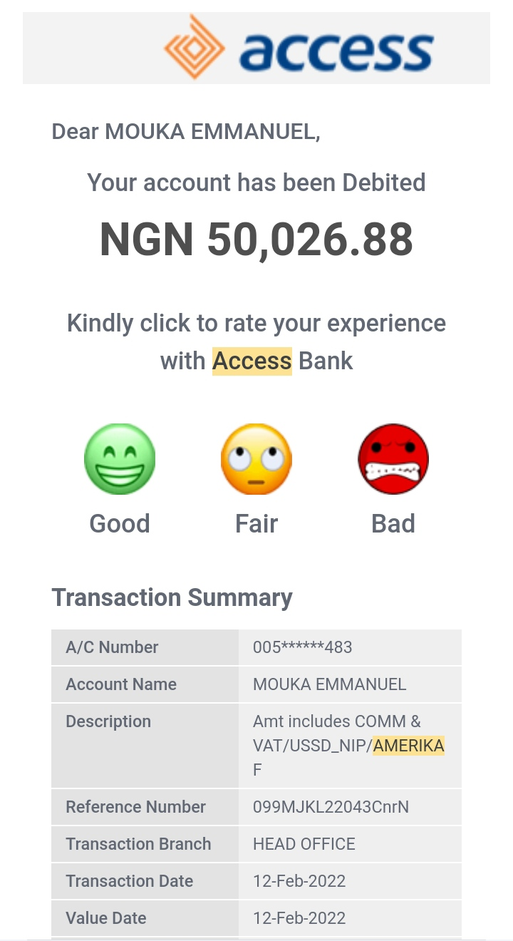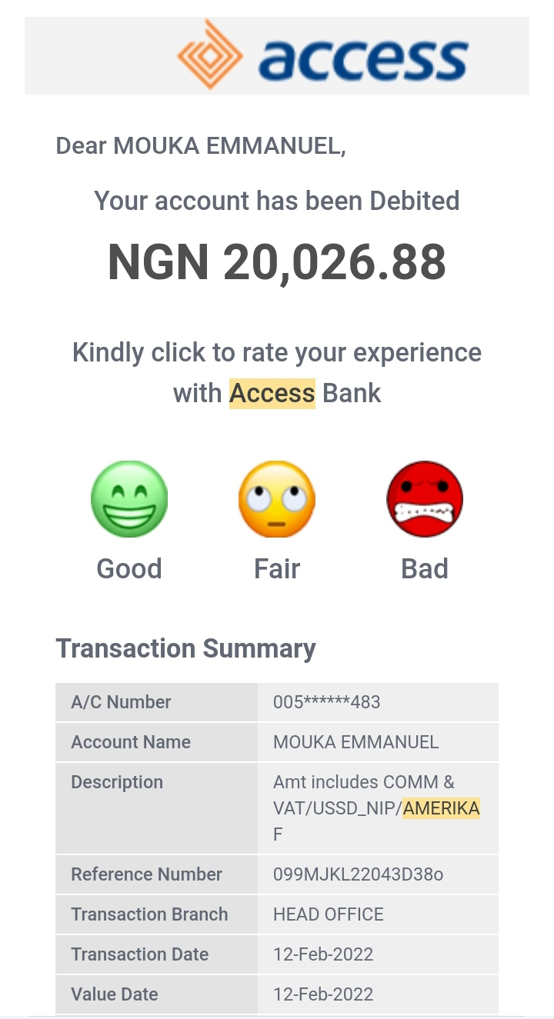**E2 - 70k to Police Officer Duke Amerika (Event on February 12,2022)**

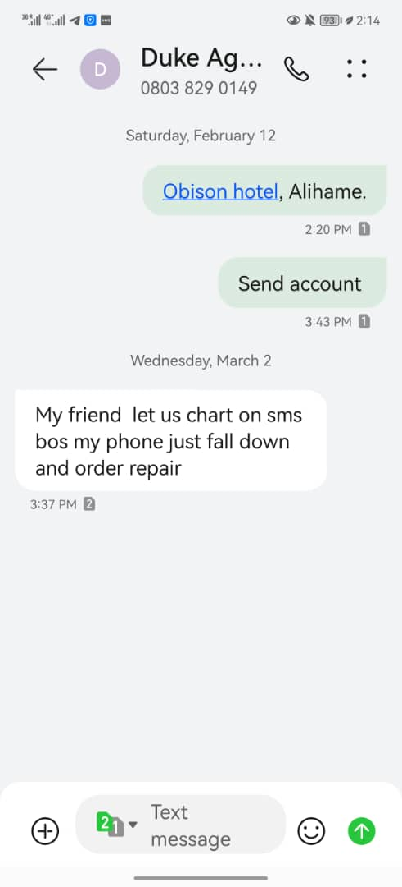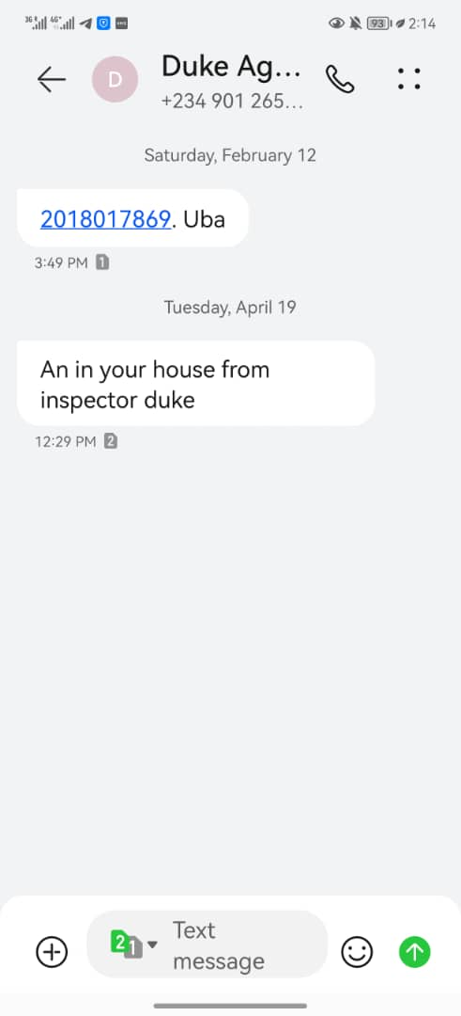**E3 - suspicious events, discovered persons at unauthorized areas, concerns and efforts to find persons.**

*Verbal confrontations in some cases if the persons are not carrying out criminal action.*

*In cases where a robbery was in progress, I do not confront the intruders but notify the police, identify what was stolen or report to persons with law enforcement capacity.*

**E4 - suspicious events, discovered persons at unauthorized areas, concerns and efforts to find persons.**

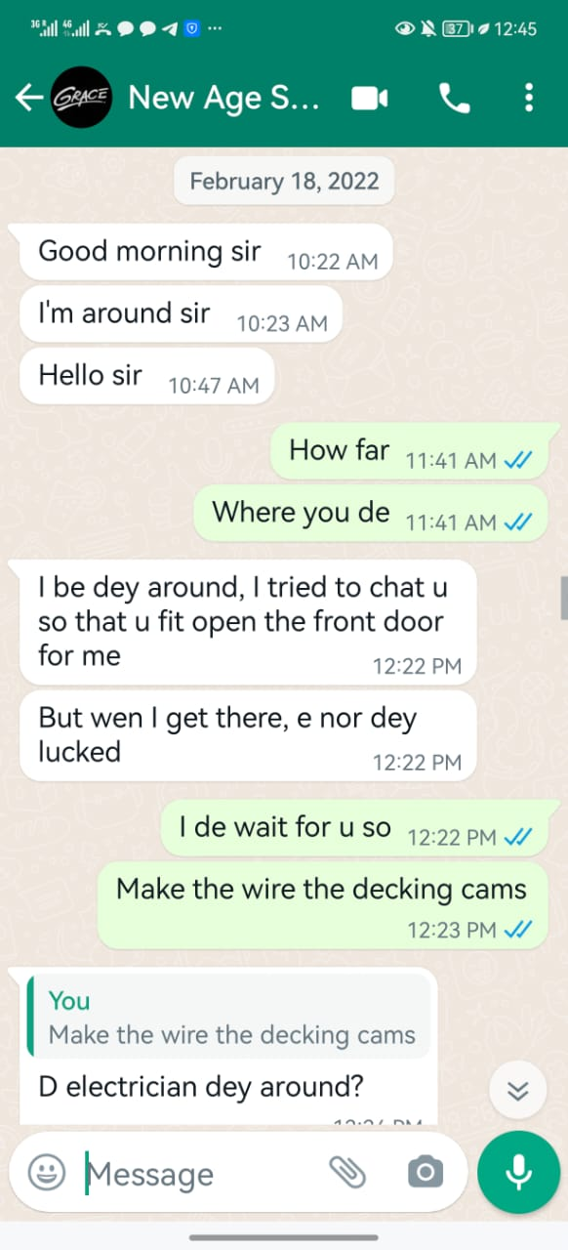**E5 - solar system**

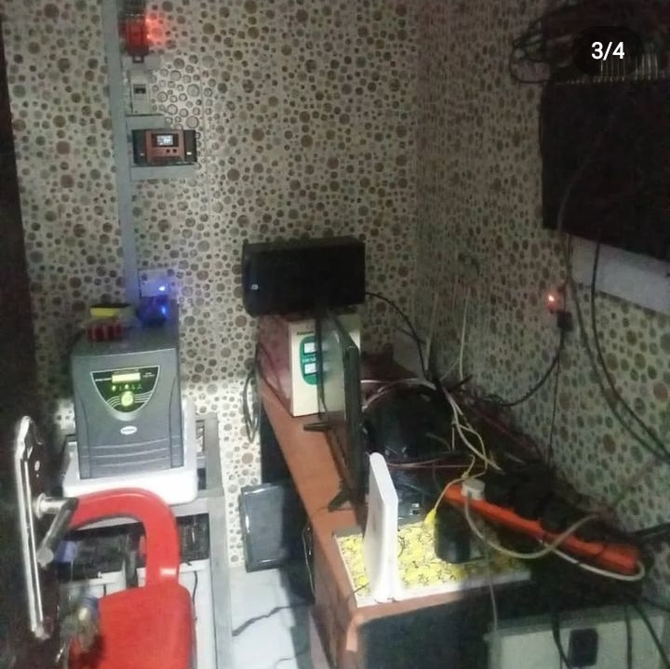

**E6 - notice of solar system not charging.**

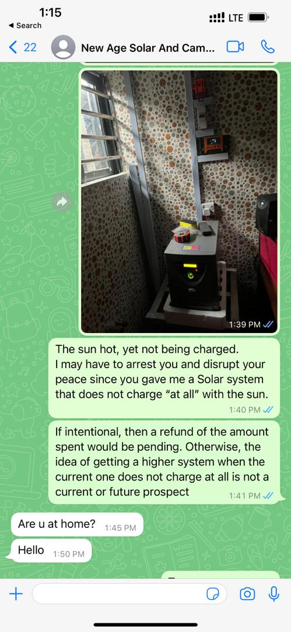**E7 - police visit, notice from police. (Event on April 19, 2022)**



**E8 - assassination attempt and property damage while in Police custody.**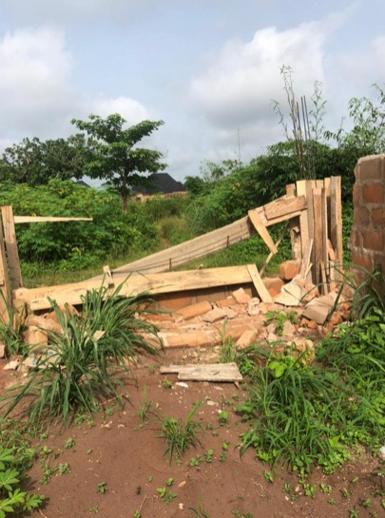

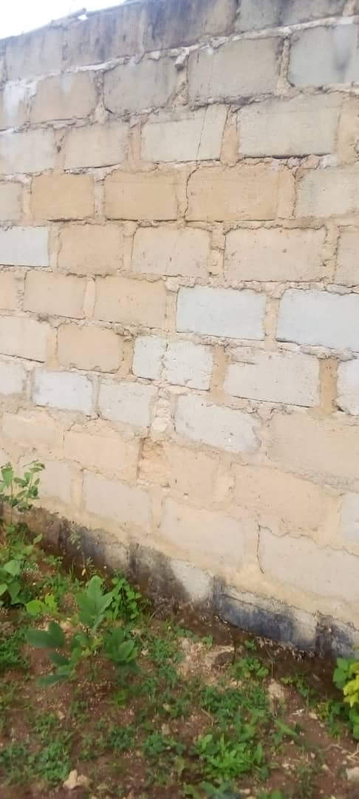

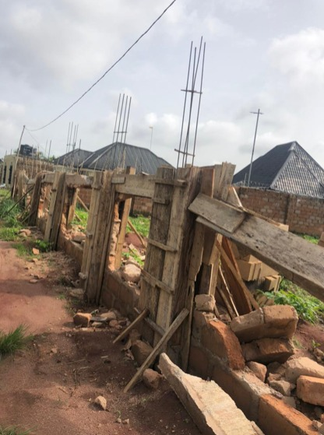**E9 - December 2021 - January 2022 blackouts on CCTV**

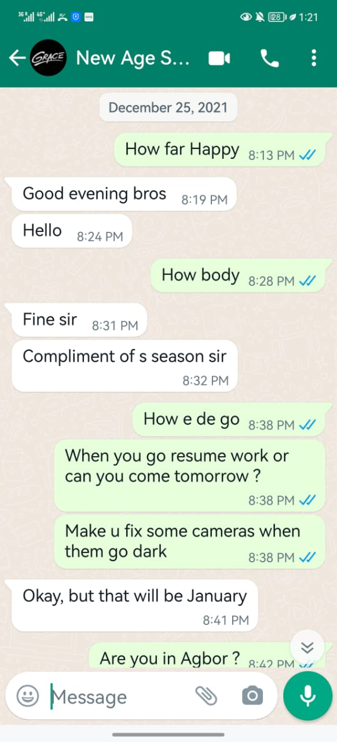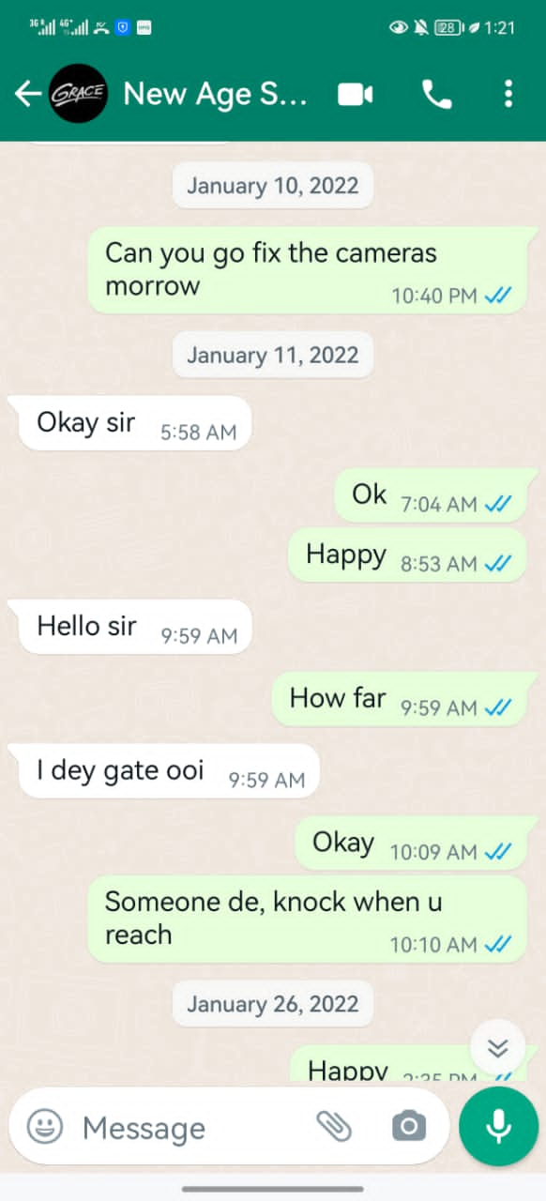

**E10 - methods of forced entry**

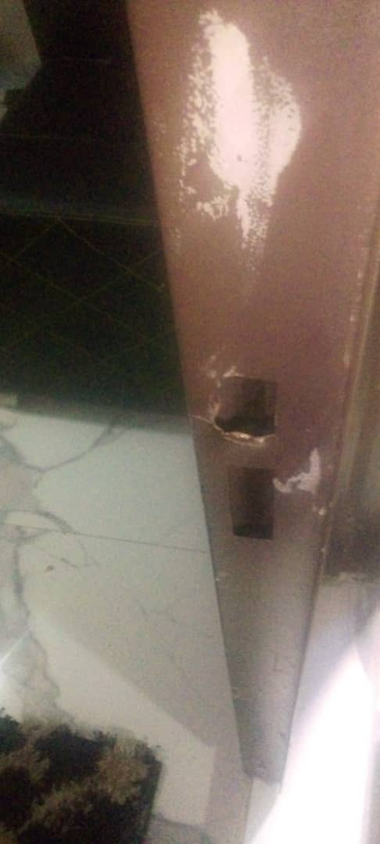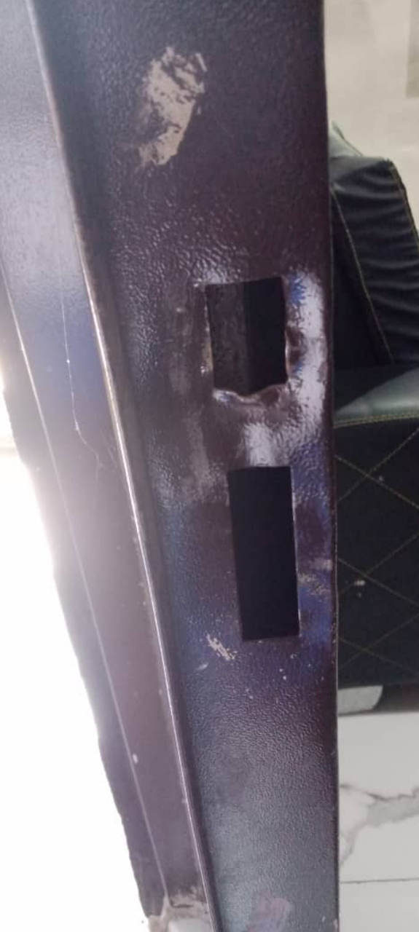

**E11 - Notice to solar company of office closing hours at 3pm. Notice to all**

**staff of closing hours at 3pm.**

